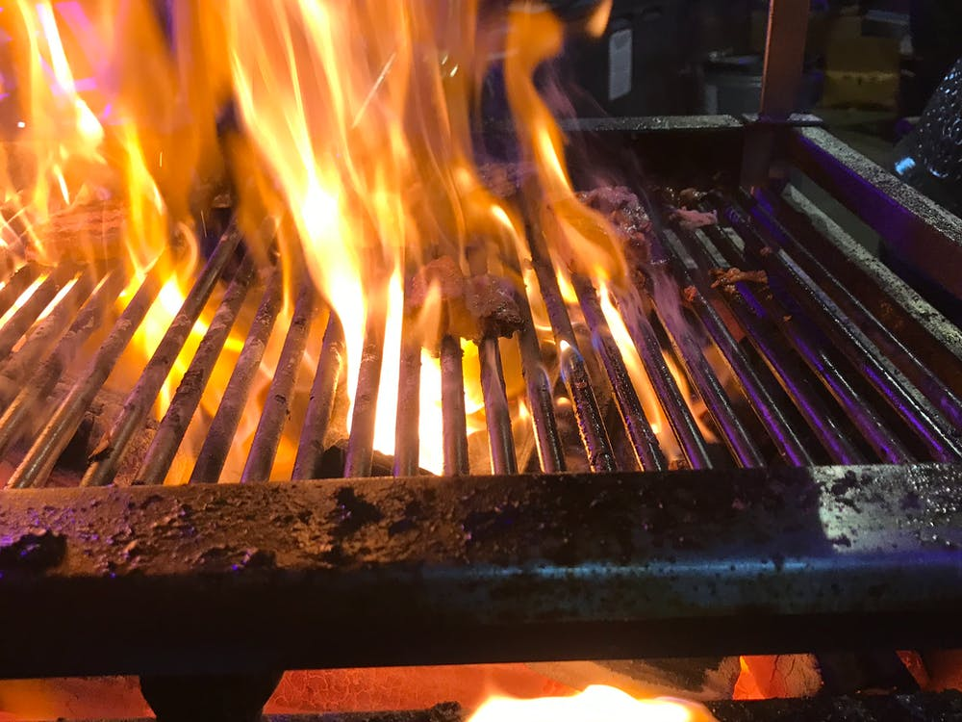

**SUMMER BBQ – FAMILY FUN AFTERNOON**

**Sunday 29th August 2021**



**BBQ £5.00 a head**

**– ticket only please for numbers**

BBQ will include choice of

Steak Mince Burgers, Chicken kebab skewers, Cumberland Sausage hotdog with selection of salads and condiments.

Meat, Courtesy of Marshalls Butchers, Workington.

Vegetarian options will be available – please state when buying your tickets.

Tea, coffee, and light refreshments served from the Stella Maris Room

3 pm to 5 pm (ish)

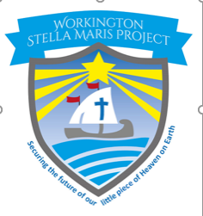

**All proceeds to the Workington Stella Maris Project**

**Dedicated to the restoration of Our Lady Star of the Sea and St Michael’s church**

**BYO**

**CHAIRS /RUGS**

**IT’S PICNIC TIME!**

STALLS

Candy floss

Pop Corn

Home produce

Scentsy

Tropic

Little Shop of Delights by Jess

Body shop at home   
Amartiste Boutique

White Elephant stall

Activities include:

* Treasure Hunt in church – Prize - £20.00 Voucher
* Hook a duck
* Guessing Booth
* Giant Connect 4
* Target shot
* Jenga and much more
* Raffle